Flight Controller

First Person View (FPV) Quadcopter

Oscar Alvarez III

Senior Design II

CMPE 4372.01

Contents

[What is a Flight Controller?](Flight%20Controller.docx" \l "What_is_a_Flight_Controller)

[FC Processors](Flight%20Controller.docx#FC_Processors)

[F1](Flight%20Controller.docx#F1)

[F3](Flight%20Controller.docx#F3)

[F4](Flight%20Controller.docx" \l "F4)

[F7](Flight%20Controller.docx" \l "F7)

[H7](Flight%20Controller.docx#H7)

[Firmware](Flight%20Controller.docx#Firmware)

[Betaflight](Flight%20Controller.docx#Betaflight)

[Raceflight](Flight%20Controller.docx#Raceflight)

[KISS](Flight%20Controller.docx#KISS)

[Hardware](Flight%20Controller.docx#Hardware)

[IMU- Gyroscope & Accelerometer](Flight%20Controller.docx#IMU)

[UART](Flight%20Controller.docx#UART)

[PID, PID Tuning and PID Analyzers](Flight%20Controller.docx#PID)

[Additional Sensors](Flight%20Controller.docx#Additional_Sensors)

[GPS integration](Flight%20Controller.docx#GPS)

[Current Sensors](Flight%20Controller.docx#Current)

[Barometer](Flight%20Controller.docx#Barometer)

[Additional Features](Flight%20Controller.docx#Additional_Features)

[On Screen Display (OSD)](Flight%20Controller.docx#OSD)

[Power Distribution Board (PDB)](Flight%20Controller.docx#PDB)

[Battery Elimination Circuit (BEC)](Flight%20Controller.docx#BEC)

[Black Box](Flight%20Controller.docx#Black_Box)

[ESC Integration](Flight%20Controller.docx#ESC)

[Receiver Compatibility](Flight%20Controller.docx#Receiver)

[Soft Mounting](Flight%20Controller.docx#Soft_Mounting)

[Mounting Patterns](Flight%20Controller.docx#Mounting_Patterns)

What is a Flight Controller (FC)?

A flight controller is a circuit board, comprised of multiple hardware components, that manages the drone’s capability to perform. It is the CPU, the brain of the quadcopter, and depending on the processor used, can provide additional functions.

FC Processors

The processors mentioned in this document will cover a range of STM32 Microcontrollers (MCUs) that are most commonly used in First Person View (FPV) Quadcopters.

|  |  |  |  |
| --- | --- | --- | --- |
| Processor | Processor Speed | # of UARTs | Flash Memory |
|  |  |  |  |
| F1 | 72MHz | 2 | 128KB |
| F3 | 72MHz | 3 | 256KB |
| F4 | 128MHz | 3 | 1MB |
| F7 | 216MHz | 3 | 1MB |
| H7 | 480MHz | TBC | 128KB |
|  |  |  |  |

**F1 Processor**

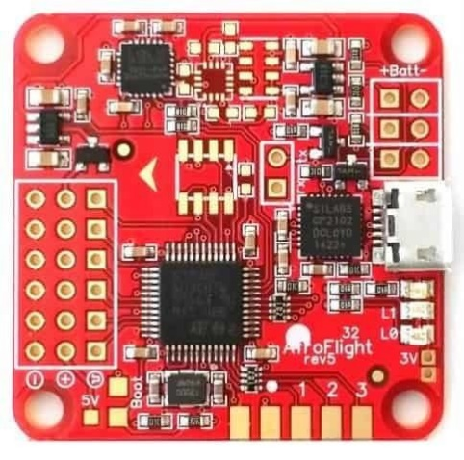Is the oldest and slowest of the STM32 processor families

and is considered outdated.

|  |  |  |  |
| --- | --- | --- | --- |
| Flight Controller | Processor | Price | Documentation |
| [Naze32 rev6](https://www.cyclonefpv.com/products/full-naze32-flight-controller-rev6-w-pin-headers?variant=14223674343483&currency=USD&utm_campaign=gs-2019-09-11&utm_source=google&utm_medium=smart_campaign&gclid=CjwKCAjwlovtBRBrEiwAG3XJ-6SGiDTE28_V-ZEimhMPibqLCESJo0-7R7TrunBW15_n_iUdoznyJBoChoYQAvD_BwE) | F1 | $19.99 | [[click here]](FC_Docs/Naze32_rev6_manual_v1.2.pdf) |
| [CC3D](https://usa.banggood.com/Betaflight-Openpilot-CC3D-Pro-Flight-Controller-3S-with-Protective-Case-for-RC-Drone-FPV-Racing-p-1428906.html?gmcCountry=US&currency=USD&createTmp=1&utm_source=googleshopping&utm_medium=cpc_bgcs&utm_content=frank&utm_campaign=ssc-usg-all-0911&ad_id=381967875983&gclid=CjwKCAjwlovtBRBrEiwAG3XJ-7GWOD1dfqxmeMTOao06G_YP0OWQ2PgKbsVC0tlP7KPeETl2_FAS7xoCCl4QAvD_BwE&ID=566985566917&cur_warehouse=CN) | F1 | $10.07 | [[click here]](FC_Docs/CC3D%20flight%20control%20board.pdf) |
| [Flip32](https://www.readytoflyquads.com/the-flip32) | F1 | $15.00 | [[click here]](FC_Docs/Flip32+_User_Manual.pdf) |

**F3 Processor**

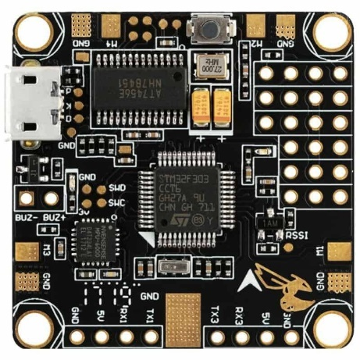Is essentially the F1 processor with an increased number of

UARTs.

|  |  |  |  |
| --- | --- | --- | --- |
| Flight Controller | Processor | Price | Documentation |
| [X-Racer](https://www.amazon.com/Crazepony-Controller-Specially-Multirotor-Quadcopter/dp/B01KFOVOFK/ref=cm_cr_arp_d_product_top?ie=UTF8) | F3 | -- | [[click here]](FC_Docs/xracerf303.pdf) |
| [Betaflight F3](https://www.getfpv.com/betaflight-f3-flight-controller.html) | F3 | $42.99 | [[click here]](https://blog.dronetrest.com/how-to-configure-the-martian-iii-fpv-quacopter-in-betaflight/) |
| [KISS FC V1](https://www.flyduino.net/en_US/shop/product/pr1872-kiss-fc-32bit-flight-controller-v1-03-2686) | F3 | $19.99 | [[click here]](FC_Docs/Flyduino-KISS-FlightController-Manual-v1.06-en.pdf) |

**F4 Processor**

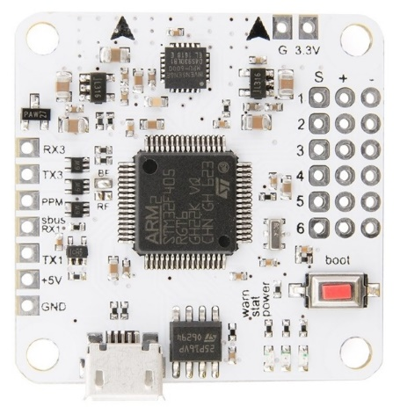Has double the processing power of the F3 and is a popular

choice for most quadcopter enthusiasts.

|  |  |  |  |
| --- | --- | --- | --- |
| Flight Controller | Processor | Price | Documentation |
| [Kakute F4](https://www.getfpv.com/holybro-kakute-f4-v2-non-aio-flight-controller.html?utm_source=google&utm_medium=cpc&adpos=1o1&scid=scplp8539&sc_intid=8539&gclid=CjwKCAjwlovtBRBrEiwAG3XJ--HzKca-kAuWvmC-8kN2sc6E8t4_HH2V-sPnPw-CeREzBdttGOj2ohoC5rsQAvD_BwE) | F4 | $36.00 | [[click here]](FC_Docs/KakuteF4V2Manual.pdf) |
| [DYS F4](https://www.racedayquads.com/products/dys-aio-f4-flight-controller-v2-fc?variant=44054516819&currency=USD&gclid=CjwKCAjwlovtBRBrEiwAG3XJ-8mxFnGqkCzFR5oJBzmnVwboZ-PhNIDgkCnkgE5DihpTBHqF2jqhRBoCnlgQAvD_BwE) | F4 | $26.70 | [[click here]](FC_Docs/F4%20PRO%20manual.pdf) |
| [Matek CTR](https://www.racedayquads.com/products/matek-f405-ctr-flight-controller?variant=3344557015051&currency=USD&gclid=CjwKCAjwlovtBRBrEiwAG3XJ-wWyNWdVjErpacmPRFD-1Po2c21yVfVHXH3PrXkhVTwqwNaQXIFWdxoCZnQQAvD_BwE) | F4 | $39.99 | [[click here]](http://www.mateksys.com/?portfolio=f405-ctr#tab-id-1) |

**F7 Processor**

Is the newest generation of the previously mentioned

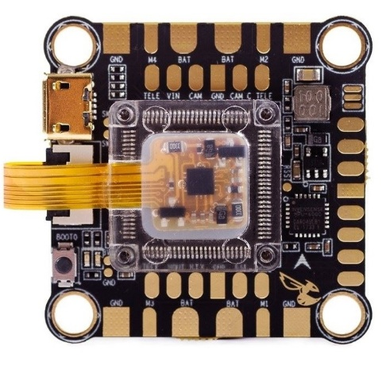processors. Contains 8 UARTS allowing for multiple

components to be used.

|  |  |  |  |
| --- | --- | --- | --- |
| Flight Controller | Processor | Price | Documentation |
| [Kakute F7](https://usa.banggood.com/Holybro-Kakute-F7-AIO-V1_5-STM32F745-Flight-Controller-w-OSD-PDB-Current-Sensor-Barometer-for-RC-Drone-p-1317570.html?gmcCountry=US&currency=USD&createTmp=1&utm_source=googleshopping&utm_medium=cpc_bgcs&utm_content=frank&utm_campaign=ssc-usg-all-newcustom-1008&ad_id=388194796019&gclid=CjwKCAjwlovtBRBrEiwAG3XJ-_a-gFXhxOEH16xvNlw3MLMFLg93_L4jlp5PJrGPi4d9hB1krXPbsxoCJdUQAvD_BwE&cur_warehouse=CN) | F7 | $49.00 | [[click here]](FC_Docs/Holybro_Kakute_F7_Manual.pdf) |
| [Betaflight F7](https://www.getfpv.com/betaflight-f7-flight-controller.html) | F7 | $59.99 | [[click here]](FC_Docs/BetaflightF7.pdf) |
| [SP Racing F7](https://www.getfpv.com/sp-racing-f7-dual-flight-controller.html) | F7 | $54.99 | [[click here]](FC_Docs/SPRacingF7DUAL-Manual-latest.pdf) |

**H7 Processor**

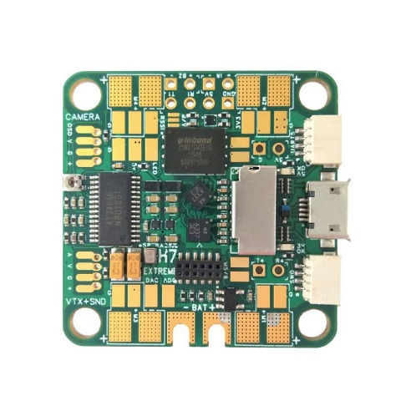

The first and only of its kind so far, made by Seriously

Pro Racing, overwhelms its predecessors in processing

power with a whopping 480MHz clock speed.

|  |  |  |  |
| --- | --- | --- | --- |
| Flight Controller | Processor | Price | Documentation |
| [SP H7](https://www.getfpv.com/sp-racing-h7-extreme-flight-controller.html) | H7 | $66.90 | [[click here]](FC_Docs/SPRacingH7EXTREME-Manual-latest.pdf) |

Firmware

The following firmware are some of the most popular used.

**Betaflight**

Has an easy to use graphical user interface (GUI) and is constantly being maintained. It is the popular pick for those with little to no coding experience and supports a wide variety of flight controllers.

**Raceflight**

As its name implies, this firmware provides the tools necessary for competitive quadcopter racing. It will also delete anything that it deems not racing relevant to free up processing power. May not be compatible to many flight controllers.

**KISS**

Is a closed source firmware developed by Flyduino. This firmware is constantly up to date with powerful products and all the latest trends. Known as the Apple of the mini quadcopters.

Hardware

The Flight Controller should at least have the following hardware capabilities in order to properly function. Anything more will be determined by the processing capabilities of the FC. The more processing power, the more you’re able to add to the FC’s capabilities.

**IMU Gyroscope/Accelerometer**

The Inertial Measurement houses the Gyroscope and the Accelerometer. The accelerometer helps determine the acceleration and the orientation of the device while the Gyroscope measures the angular orientation by adding a dimension. The two major gyroscopes used for quadcopters are the MPU6000 (commonly found in F4s) and the ICM20602 (commonly found in F7s). Some FCs utilize both gyros (are switched based on preference). The ICM20602 is known to be the better of the two. The figure below shows the orientations of axes of sensitivity and polarity of rotation for the accelerometer and gyroscope.

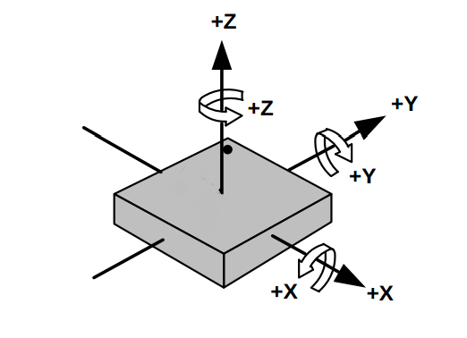

**UART**

The Universal Asynchronous Receiver/Transmitter (UART), is an interface that allows you to communicate with a device. A UART will contain a port to transmit, and a port to receive data. The number of UARTs an FC contains will determine up to how many components you can communicate with you quadcopter at a time.

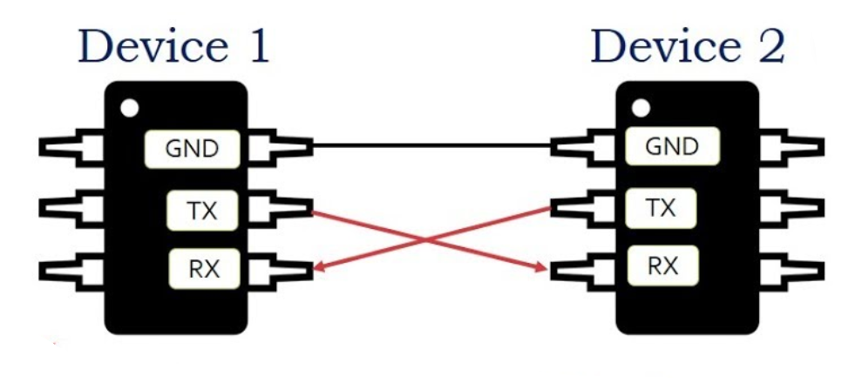

**PID, PID Tuning and PID Analyzers**

Proportional, Integral, and Derivative, the PID is used to compensate for any errors that are read in from the sensors. The “P” parameter manages the orientation of the quadcopter by adjusting the motors’ power in response to user input. Changing “P” will affect the responsiveness of your drone. The “I” parameter looks for errors caused by wind, or obstacles (crashing), and will do its best to maintain the quads orientation. The “D” parameter will soften the effects of “P” in order to prevent the quad from overshooting the users inputs. If your FC contains a black box feature, a PID Analyzer can be used to read through its logs in order to help calculate a PID response to certain events that may prevent the quadcopter from performing smoothly.

Additional Sensors

Depending on your FC, you may or may not have some of the following hardware components. If not, and you have the UART ports, you can always add it to your quad.

**GPS Integration**

Most beginner drones don’t have global positioning systems as they rarely have the capability to go beyond your sight. Having a GPS on your drone can help with locating those that can fly long distances in order to prevent losing it. Autonomous projects that involve aerial mapping rely heavily on GPS Integration.



**Current Sensors**

Current Sensors are used to measure the current flowing through your quadcopter. This helps monitor the current usage and prevents any unnecessary battery damage/drainage.

**Barometer**

A barometer measures the altitude by sensing the change in atmospheric pressure. Autonomous navigation uses the barometer to ensure it maintains the required altitude as it travels along path.

Additional Features

Depending on your FC, you may have some of the following features included. Check with your FC documentation to verify.

**On Screen Display (OSD)**

The OSD can grab any relevant sensor data from your FC and display it along with any video stream from your quadcopter. Information such as altitude, velocity, temperature, and battery life can all be displayed.

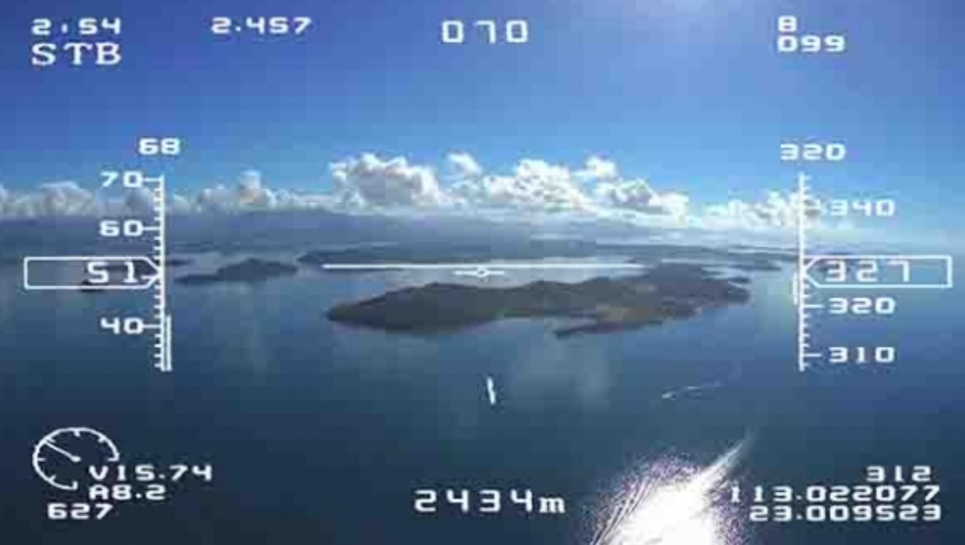

**Power Distribution Board (PDB)**

Most FCs are now in the form of an integrated PDB. This helped reduce the stack size by 15mm, helping conserve space and mass.

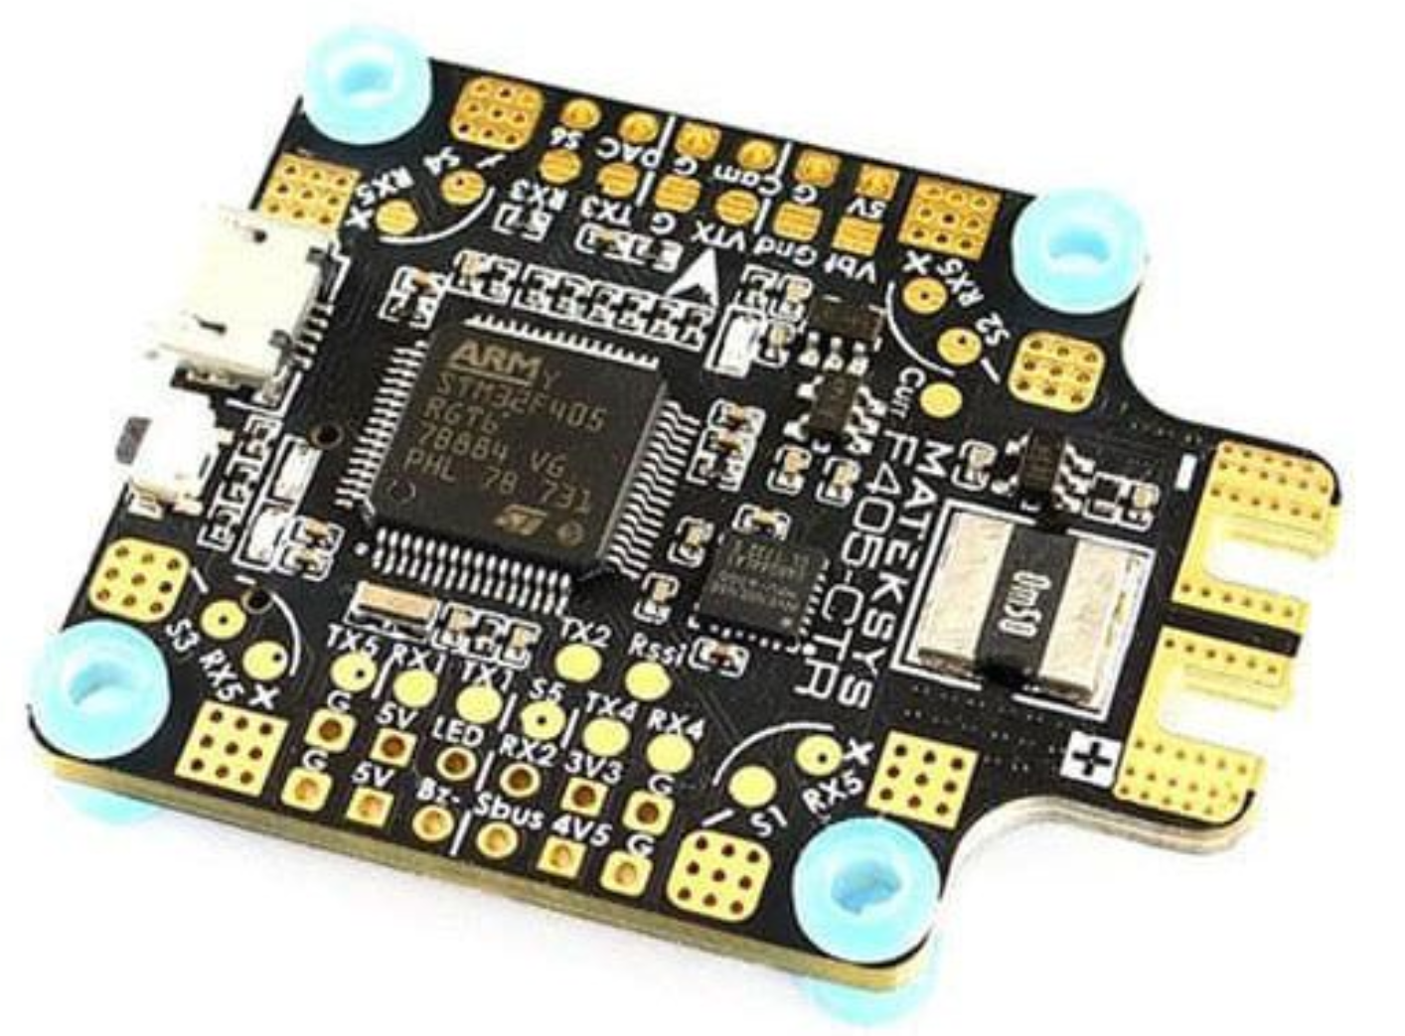

**Battery Elimination Circuit (BEC)**

Allows electrical power to be delivered to other components without the use of multiple power sources. Usually the components don’t need that much power, so the BEC will drop the high voltage of the battery to a lower voltage to power them.

**Black Box**

A black box records data from current sensors and checks for vibrations and oscillations that abnormally occur on the quadcopter. The data can then be reviewed and analyzed by the PID Analyzer in order to apply the appropriate correction. Great for tuning up your quadcopter.

**ESC Integration**

Some FCs are integrated with an Electronic Speed Controller, a device used to give precise instructions to the motors on the quadcopter to help control movement. Also provides motor reversal capabilities and dynamic braking. Can only handle low currents without risking damage to the flight controller.

**Receiver Compatibility**

Most FCs have receiver compatibility, meaning you can transmit to it. Check FC documentation to see what kind of receiver protocols are supported by your device.

**Soft Mounting**

Regardless of how well tuned your motors are, vibrations are unavoidable. To prevent the gyroscope sensitivity from making your quadcopter unflyable, soft mounting is integrated into the device in order to absorb the vibrations.

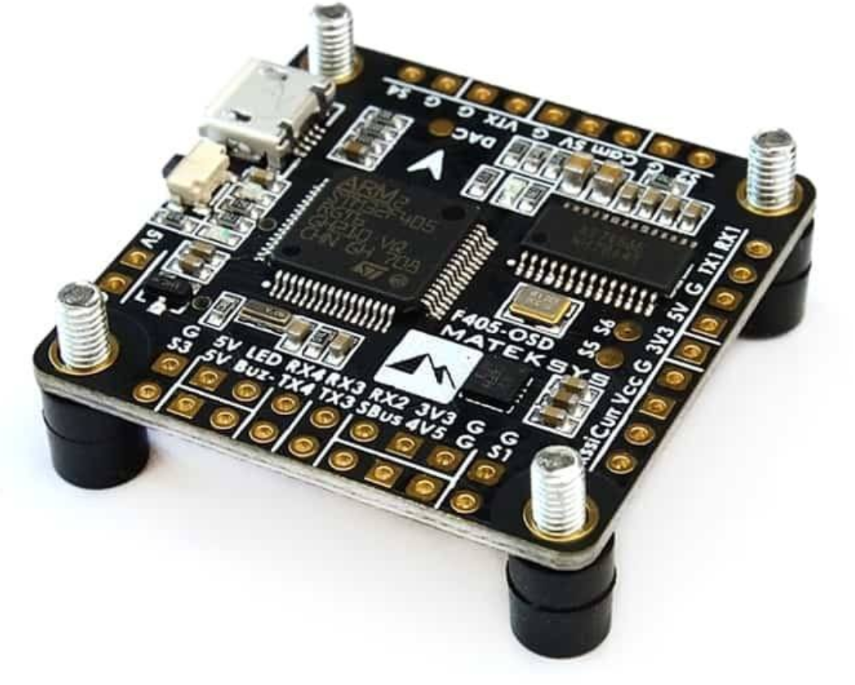

**Mounting Patterns**

Most FCs will keep the same mounting patterns in order to maintain compatibility with other devices, making it capable of stacking neatly. Most of the devices will have the same size four holes on each corner with the same distance in between them for convenience.

